GLOBAL LEADERSHIP CERTIFICATE COURSE ACCESS INSTRUCTIONS

1. Sign into [Kiwanis Connect](https://members.kiwanis.org/SignIn/Index?returnUrl=https://reporting.kiwanisone.org:443/Account/ResolveFederatedToken?returnUrl=%252F&instant=True). If you do not have a password to the Kiwanis Connect page, click “Set your password here.”

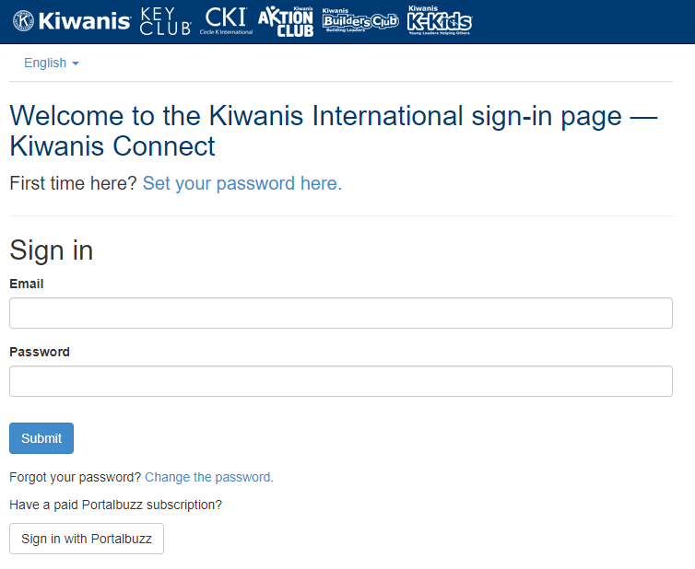

1. Once you click to set your password, enter your email username. Be sure to use the same personal email address that is listed in your club's roster. Ask your Key Club faculty advisor if you don’t know what email address was used. Enter your email address and set your new password.
2. Check your email for a link to complete your password setup.
3. When your password is set, return to Kiwanis Connect and sign in using your new password.
4. Once logged in to your personal Me page, select hyperlink "Click here to access Global Leadership Certi­ficate courses.”

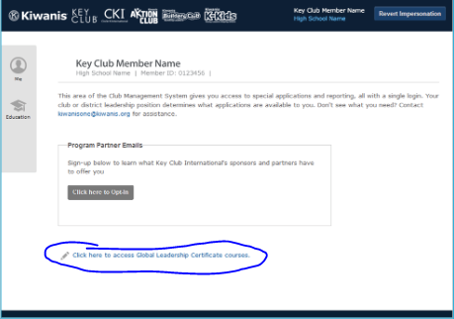

1. Under the Dashboard's Featured Courses, click on the orange Launch Program button. A new web browser will open with the full list of courses.
2. Begin taking the courses!

Here is a suggested order to complete the Global Leadership Certi­ficate courses for Key Club. If you have technical questions, please submit a helpdesk form via [Global Leadership Certi­ficate Key Club International.](https://kiwanis.formstack.com/forms/glc_key_helpdesk)